Counterfeit Medicine Detection Using Computer Vision and Siamese Neural Networks
Submitted by

S.SOWNDARYA - 22MIA1106
S.BHAVYA SRI - 22MIA1010
CSE3089 - COMPUTER VISION
SLOT - D2
Under the Guidance of
Dr REENA ROY R

Integrated M.Tech – Computer Science and Engineering (Business Analytics)
SCHOOL OF COMPUTER SCIENCE AND ENGINEERING (SCOPE)



WINTER SEMESTER 2025–26

ABSTRACT
Counterfeit medicines pose a serious threat to global healthcare systems, leading to significant health risks and economic losses. Traditional verification methods such as barcode scanning and RFID systems are often ineffective due to their susceptibility to duplication and additional infrastructure requirements. This paper presents a computer vision-based approach for detecting counterfeit medicines using a Siamese Neural Network. The system compares images of medicine packaging to determine their authenticity based on visual similarity. A custom dataset was developed consisting of genuine medicine images and synthetically generated counterfeit samples created using data augmentation and semantic modifications. The model was trained using contrastive learning and evaluated using multiple performance metrics. Experimental results demonstrate that the proposed approach achieves an accuracy of approximately 76.9% with a high F1-score, indicating its effectiveness in identifying counterfeit packaging. The system is further deployed as a user-friendly web application for real-time detection.
KEY WORDS

computer vision, counterfeit detection, image similarity, siamese neural network

TABLE OF CONTENTS
1 | Introduction | 3
2 | Problem Statement | 4
3 | Literature Review | 4
4 | Dataset Creation | 5
5 | System Architecture | 6
6 | Model Architecture (Siamese Neural Network) | 7
7 | Training Strategy | 8
8 | Implementation Details | 10
9 | Results and Discussion | 10
10 | Web Application Demo | 11
11 | Limitations | 12
12 | Conclusion | 14
13 | Future Work | 15
14 | References | 16

1. INTRODUCTION
Counterfeit medicines are a growing global concern that pose significant risks to patient safety and public health. These counterfeit products often contain incorrect or harmful ingredients, leading to ineffective treatment and severe medical complications. According to the World Health Organization (WHO), approximately 10% of medicines in the global pharmaceutical market are counterfeit, contributing to millions of deaths annually.
Traditional methods of authentication, such as barcodes and RFID tags, are widely used but have serious limitations including ease of duplication, high implementation costs, and the requirement for specialized scanning infrastructure. These methods fail to detect visually replicated packaging that mimics the appearance of genuine products.
With the advancement of artificial intelligence and deep learning, computer vision techniques offer a promising alternative for detecting counterfeit products. By analyzing visual features such as packaging design, color patterns, logo placement, and structural layout, machine learning models can identify inconsistencies between genuine and counterfeit medicines without any additional hardware.
This project proposes a Siamese Neural Network-based system that compares medicine packaging images to determine their authenticity. The system focuses on learning visual similarity patterns between image pairs, enabling automated and scalable counterfeit detection. A user-friendly web application was also developed using Streamlit to demonstrate the system in real time.

2. PROBLEM STATEMENT
Counterfeit medicines represent a critical issue in healthcare, as they can lead to ineffective treatments and serious health risks. Existing verification methods such as barcode systems and RFID tags are often unreliable due to duplication vulnerabilities and infrastructure requirements.
There is a need for an intelligent system that:
- Detects counterfeit medicines using visual analysis
- Does not require additional hardware
- Works effectively with limited labeled data
- Provides real-time results through an accessible interface
This project aims to address these challenges using a deep learning-based image similarity approach.
3. LITERATURE REVIEW TABLE

REF NO | Author(s) | Title (short) | Method Used | Accuracy / Result
[1] | Motwani et al. | Counterfeit Medicine Detection using DL | CNN + Object Detection | -
[2] | Ramos et al. | Medicine Authentication using CNN | SVM + CNN | Promising results
[3] | Thomson & Varuna | DL Forecasting of Counterfeit Medicines | BO-CNN | 81.43%
[4] | Koch et al. | Siamese NN for One-shot Recognition | Siamese + Contrastive Loss | Benchmark
[5] | Simo-Serra et al. | Deep Conv Feature Descriptors | CNN Feature Matching | SOTA
[6] | Chicco | Siamese Neural Networks: Overview | Survey | -
[7] | Lu et al. | Siamese NN for Seal Recognition | Multi-stage Siamese | High accuracy
[8] | Demir & Koperski | Survey on Siamese NN in CV | Survey | -
[9] | Lin et al. | Drug ID using Deep Learning | Deep Learning | >90%
[10] | He et al. | Deep Residual Learning (ResNet) | ResNet | SOTA
[11] | Bromley et al. | Signature Verification Siamese NN | Siamese (original) | Foundational
[12] | Chopra et al. | Signature Verification Siamese NN | Contrastive Loss | Foundational
[13] | Ignatov et al. | DL for Product Packaging Recognition | CNN | High accuracy
[14] | Adedeji & Wang | AI App for Counterfeit Detection (Nigeria) | YOLO-NAS + OCR | -

4. DATASET CREATION
A custom dataset was developed consisting of multiple medicine packaging images collected manually under different conditions.
- 16 different medicine types
- 5–6 images per medicine
- Images captured under varying lighting, angle, and distance
To improve dataset diversity, augmentation techniques such as rotation, brightness adjustment, noise addition, and blurring were applied.
Counterfeit samples were synthetically generated using:
- Visual distortions (blur, noise, occlusion)
- Text modifications (spelling changes, font changes)
- Logo and layout alterations
This approach ensured the model learns both visual and structural differences between genuine and counterfeit images.
5. SYSTEM ARCHITECTURE
The overall system architecture follows a structured pipeline for counterfeit detection. The pipeline consists of the following stages:
- ﻿﻿﻿Two input images are provided to the system — one Reference Image (genuine) and one
Test Image (to be verified)
- ﻿﻿﻿Both images are preprocessed: resized to 128x128 pixels and normalized
- ﻿﻿﻿Images are passed through the Siamese Neural Network for feature extraction
- ﻿﻿﻿Feature vectors (embeddings) from both images are extracted
- ﻿﻿﻿Euclidean distance is computed between the two feature vectors
- ﻿﻿﻿A predefined threshold of 0.7 is applied to the distance score
- ﻿﻿﻿Final output: GENUINE if distance is below threshold, COUNTERFEIT if above

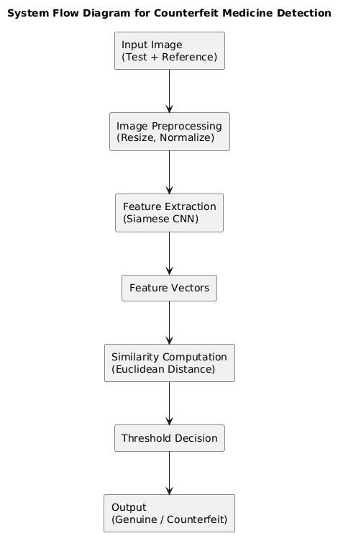

6. MODEL ARCHITECTURE (SIAMESE NEURAL NETWORK)
The proposed model is based on a Siamese Neural Network (SNN) architecture designed to learn similarity between pairs of medicine packaging images. Unlike traditional classification models, this architecture compares two input images and determines whether they are similar (genuine) or dissimilar (counterfeit).
The network consists of two identical convolutional neural network (CNN) branches with shared weights, ensuring that both input images are processed using the same feature extraction pipeline. This shared-weight mechanism guarantees consistent feature representation and reduces the number of trainable parameters.
Each branch takes an input image and processes it through a pretrained ResNet18 model, which acts as the feature extractor. ResNet18 is selected due to its ability to capture high-level visual features efficiently while maintaining computational simplicity. The output of each branch is a fixed-length feature vector (embedding) that represents important visual attributes such as color distribution, texture, structural layout, and logo positioning.
Once the feature vectors are obtained, the similarity between the two images is computed using the Euclidean distance metric. This distance reflects how close the two embeddings are in the feature space. A smaller distance indicates higher similarity, whereas a larger distance indicates dissimilarity.
To generate the final prediction, a threshold-based classification is applied. A threshold value of 0.7 is used, where:
- Distance < 0.7 → Genuine
- Distance ≥ 0.7 → Counterfeit
This threshold was selected through experimental evaluation to achieve an optimal balance between precision and recall.
The overall architecture enables the model to focus on learning relationships between images rather than memorizing class labels. This makes it particularly effective for problems with limited data and allows the system to generalize well to unseen medicine packaging.

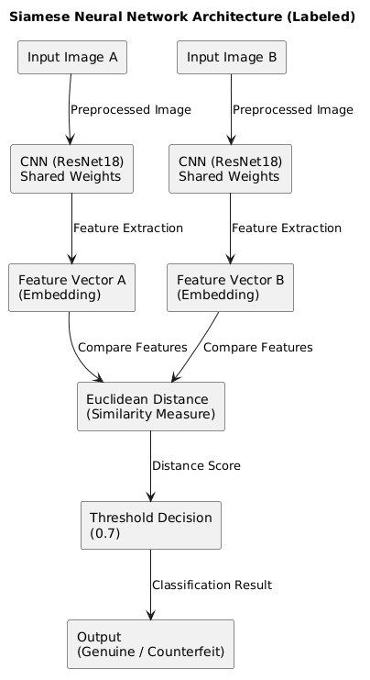

7. TRAINING STRATEGY
The Siamese Neural Network was trained using pairs of images labeled based on their similarity. Two types of image pairs were generated from the dataset:
- Similar pairs (label = 1): Two genuine images of the same medicine
- Dissimilar pairs (label = 0): One genuine image and one counterfeit image
This pairing strategy enables the model to learn the relationship between images rather than memorizing class labels.
The model was trained using contrastive loss, which is specifically designed for similarity learning. This loss function minimizes the distance between feature vectors of similar image pairs while maximizing the distance between dissimilar pairs. As a result, the model learns to bring genuine images closer in the feature space and push counterfeit images farther apart.
A pretrained ResNet18 model was used as the backbone for feature extraction, and training was performed using the PyTorch framework. The Adam optimizer was used to update model parameters, providing efficient convergence.
All input images were resized to 128 × 128 pixels to ensure uniformity and reduce computational complexity. The training process was carried out on Google Colab using GPU (Tesla T4) to accelerate computation.
During training, the loss value was monitored across epochs. A steady decrease in loss indicated that the model was effectively learning similarity patterns. Additionally, threshold tuning was performed after training to determine the optimal distance value for classification. A threshold of 0.7 was selected based on experimental evaluation to achieve a balance between precision and recall.

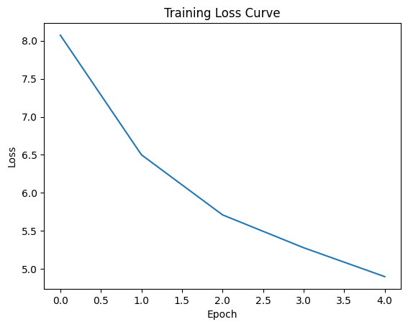

8. IMPLEMENTATION DETAILS
The proposed system was implemented using Python as the primary programming language. The following tools and libraries were used:
TOOL/LIBRARY | PURPOSE
Python 3.x | Primary programming language
PyTorch | Deep learning model development
OpenCV | Image preprocessing and augmentation
Streamlit | Web application development
Numpy/Pandas | Data handling
Matplotlib | Visualization (loss curve, confusion matrix)
Google colab | Training platform

9. RESULTS AND DISCUSSION
The performance of the proposed Siamese Neural Network model was evaluated using standard classification metrics on the test dataset consisting of both similar (genuine–genuine) and dissimilar (genuine–counterfeit) image pairs.
The model achieved the following results:
- Accuracy: 76.9%
- Precision: 81.2%
- Recall: 93.3%
- F1-Score: 0.86
The high recall value indicates that the model is highly effective in detecting counterfeit medicines, which is critical in healthcare applications where missing a counterfeit (false negative) can have serious consequences. The F1-score demonstrates a good balance between precision and recall, reflecting overall robustness of the model.
The confusion matrix further provides insight into classification performance. A large number of counterfeit samples were correctly identified, while some genuine samples were misclassified as counterfeit. This behavior is expected in similarity-based models, especially when counterfeit images closely resemble genuine packaging.
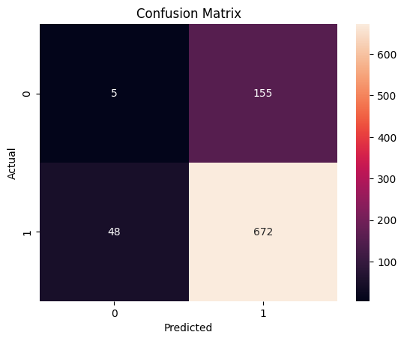
The training loss curve shows a steady decrease in loss values across epochs, indicating that the model successfully learned to distinguish between similar and dissimilar image pairs. This confirms proper convergence during training.
Additionally, threshold tuning played a significant role in improving performance. A threshold value of 0.7 was selected to achieve a balance between detecting counterfeit samples and minimizing false classifications.
Overall, the results demonstrate that the proposed approach is effective for counterfeit medicine detection using visual similarity. Compared to traditional barcode-based systems, this method provides a more flexible and scalable solution without requiring additional hardware.

10. WEB APPLICATION DEMO
To demonstrate the practical applicability of the proposed system, a web-based application was developed using the Streamlit framework. The application provides an intuitive interface that allows users to verify the authenticity of medicine packaging images in real time.
The system requires two inputs:
- A test image (medicine to be verified)
- A reference image (genuine medicine)
Once the images are uploaded, they are preprocessed and passed through the trained Siamese Neural Network model. The system computes the similarity score based on the Euclidean distance between the feature vectors and applies the predefined threshold to generate the final classification.
The application displays:
- The uploaded images side by side
- The computed similarity score
- The final result (GENUINE or COUNTERFEIT)
- A confidence level indicating prediction strength
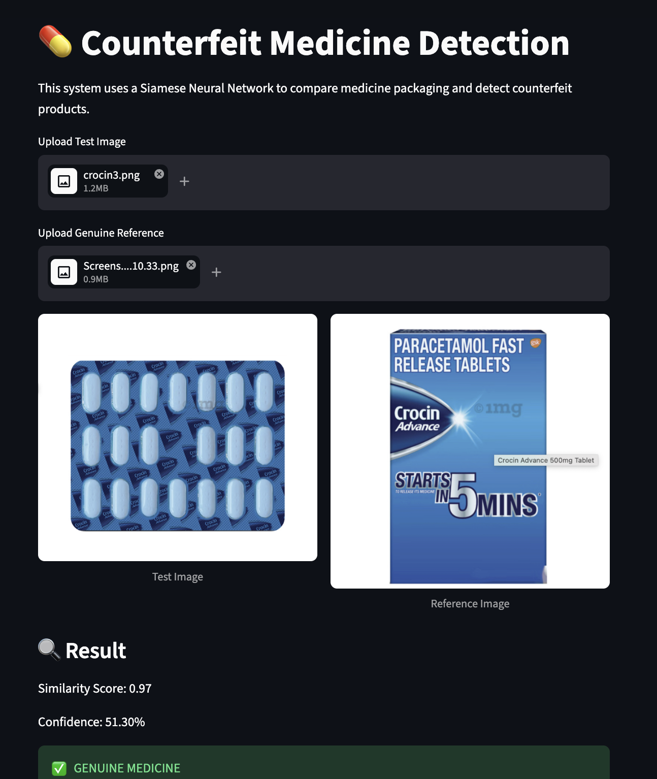
In the genuine case, the model produces a high similarity score, indicating that the test image closely matches the reference image. As a result, the system correctly classifies the medicine as genuine.
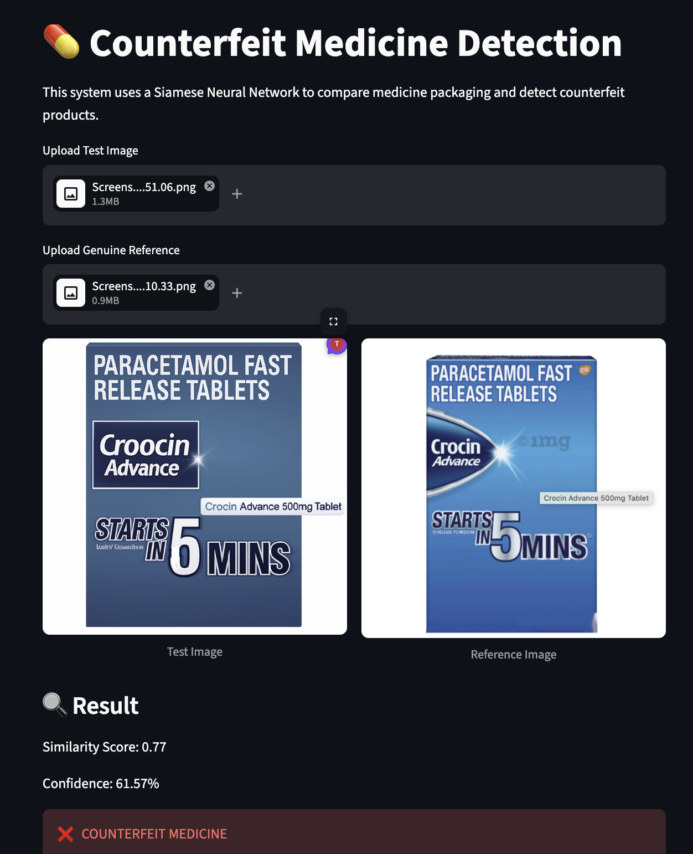
In the counterfeit case, the model detects differences in visual features such as text, layout, or color, resulting in a lower similarity score. Based on the threshold, the system classifies the input as counterfeit.
The Streamlit application demonstrates the system’s ability to perform real-time counterfeit detection without requiring specialized hardware. It provides a simple and user-friendly solution that can be used by pharmacists, healthcare professionals, and consumers.
11. LIMITATIONS
Despite achieving satisfactory performance, the proposed system has certain limitations that need to be addressed in future work.
Firstly, the model primarily relies on visual features such as color, shape, and layout of the packaging. It does not incorporate semantic understanding of textual content. As a result, it may fail to detect counterfeit samples that closely resemble genuine packaging but contain minor textual variations such as slight spelling changes or font differences.
Secondly, the dataset used for training includes synthetically generated counterfeit images, which may not fully represent real-world counterfeit scenarios. Actual counterfeit products can exhibit more complex and diverse variations, which may affect the model’s generalization ability.
Additionally, the system is trained on a limited number of medicine types (16). Scaling the model to handle a larger variety of medicines would require a significantly expanded dataset and further training.
The model performance is also sensitive to image quality. Variations such as poor lighting, blur, low resolution, or occlusion can impact feature extraction and reduce accuracy.
Finally, the use of a fixed threshold value (0.7) for classification may not be optimal for all datasets or conditions. The threshold may require adjustment when the system is applied to new environments or different medicine categories.

12. CONCLUSION
This project presents a computer vision-based approach for detecting counterfeit medicines using a Siamese Neural Network. The system compares medicine packaging images and determines their authenticity based on visual similarity, eliminating the need for additional hardware such as barcode scanners or RFID systems.
A custom dataset was created consisting of genuine and synthetically generated counterfeit samples, enabling the model to learn both visual and structural variations. The Siamese architecture, combined with a pretrained ResNet18 backbone, effectively extracts meaningful features and computes similarity using Euclidean distance.
The model achieved an accuracy of 76.9%, with high recall, demonstrating its effectiveness in identifying counterfeit medicines. The development of a Streamlit-based web application further validates the practical usability of the system by enabling real-time detection.
Overall, the proposed approach provides a scalable, cost-effective, and automated solution for counterfeit medicine detection, highlighting the potential of deep learning-based image similarity techniques in healthcare applications.

13. FUTURE WORK
Although the proposed system shows promising results, several improvements can be made to enhance its performance and real-world applicability.
One important extension is the integration of Optical Character Recognition (OCR) to analyze textual content on medicine packaging. This would enable the system to detect spelling errors, font inconsistencies, and incorrect labeling, which are common indicators of counterfeit products.
Another improvement involves expanding the dataset with real-world counterfeit samples obtained from pharmaceutical industries or regulatory bodies. This would improve the model’s ability to generalize to real-world scenarios.
The system can also be extended into a mobile application, allowing users to verify medicines directly using smartphone cameras, increasing accessibility and usability.
Further research can explore advanced techniques such as triplet loss for improved feature discrimination and multi-modal approaches that combine visual analysis with barcode or QR code verification.
Additionally, integrating the system with blockchain-based supply chain tracking could provide enhanced transparency and security in pharmaceutical distribution.
14. REFERENCES
[1] K. Motwani, R. Dsouza, R. Dsouza, and J. Jose, "Counterfeit Medicine Detection using Deep Learning," International Journal of Innovative Research in Technology (IJIRT), vol. 10, no. 3, pp. 818–823, 2023. [Online]. Available: https://ijirt.org/publishedpaper/IJIRT156491_PAPER.pdf

[2] R. R. T. Ramos, K. R. B. Samonte, and C. O. Manlises, "Medicine Authentication Based on Image Processing Using Convolutional Neural Networks," in Proc. 16th Int. Conf. on Computer and Automation Engineering (ICCAE), Melbourne, Australia, 2024, pp. 278–282.
[3] B. S. Thomson and W. R. Varuna, "Deep Learning based Forecasting and Detection of Counterfeit Medicines," SSRN Electronic Journal, 2025. [Online]. Available: https://papers.ssrn.com/sol3/papers.cfm?abstract_id=5719498

[4] G. Koch, R. Zemel, and R. Salakhutdinov, "Siamese Neural Networks for One-shot Image Recognition," in Proc. ICML Deep Learning Workshop, Lille, France, 2015, vol. 2, pp. 1–30. [Online]. Available: https://www.cs.cmu.edu/~rsalakhu/papers/oneshot1.pdf

[5] E. Simo-Serra, E. Trulls, L. Ferraz, I. Kokkinos, P. Fua, and F. Moreno-Noguer, "Discriminative Learning of Deep Convolutional Feature Point Descriptors," in Proc. IEEE Int. Conf. on Computer Vision (ICCV), Santiago, Chile, 2015, pp. 118–126. [Online]. Available: https://ieeexplore.ieee.org/document/7899663
[6] D. Chicco, "Siamese Neural Networks: An Overview," in Artificial Neural Networks, vol. 2190, Methods in Molecular Biology. New York, NY: Humana, 2021, pp. 73–94
[7] J. Lu, X. Huang, C. Li, R. Xin, S. Zhang, and M. Emam, "Multi-Stage-Based Siamese Neural Network for Seal Image Recognition," Computer Modeling in Engineering & Sciences, vol. 142, no. 1, pp. 405–423, 2025. doi: 10.32604/cmes.2024.058121
[8] I. Demir and K. M. Koperski, "A Survey on Applications of Siamese Neural Networks in Computer Vision," in Proc. IEEE Int. Conf. on Image Processing (ICIP), Abu Dhabi, UAE, 2020, pp. 1–5. [Online]. Available: https://ieeexplore.ieee.org/abstract/document/9153977
[9] C.-C. Lin, M.-H. Kuo, and H.-J. Chen, "A Drug Identification Model Developed Using Deep Learning Technologies: Experience of a Medical Center in Taiwan," BMC Health Services Research, vol. 20, no. 1, pp. 1–12, Apr. 2020. doi: 10.1186/s12913-020-05166-w
[10] K. He, X. Zhang, S. Ren, and J. Sun, "Deep Residual Learning for Image Recognition," in Proc. IEEE Conf. on Computer Vision and Pattern Recognition (CVPR), Las Vegas, NV, USA, 2016, pp. 770–778.
[11] J. Bromley, I. Guyon, Y. LeCun, E. Säckinger, and R. Shah, "Signature Verification Using a 'Siamese' Time Delay Neural Network," Advances in Neural Information Processing Systems, vol. 6, pp. 737–744, 1993.
[12] S. Chopra, R. Hadsell, and Y. LeCun, "Learning a Similarity Metric Discriminatively, with Application to Face Verification," in Proc. IEEE Conf. on Computer Vision and Pattern Recognition (CVPR), San Diego, CA, USA, 2005, vol. 1, pp. 539–546.

[13] A. Ignatov, R. Timofte, A. Bahri, K. Yu, and L. Van Gool, "Advances in Deep Learning-based Image Recognition of Product Packaging," Image and Vision Computing, vol. 127, Nov. 2022. doi: 10.1016/j.imavis.2022.104540
[14] O. Adedeji and Z. Wang, "Development of an AI-based Application for Counterfeit Medicine Detection in the Nigerian Drug Market," ResearchGate, 2025. [Online]. Available: https://www.researchgate.net/publication/392150130

